INDIAN INSTITUTE OF INFORMATION TECHNOLOGY VADODARA



GROUP PROJECT

QUILL (PRODUCTIVITY APP)

Course / Subject : CS261
Academic Year 2026–27

GROUP MEMBERS
Rohan Chaudhari : 20251501148
VISHAL KUMAR : 20251501177
Yash shete : 20251501178
Yatharth Singh : 20251501179
Vaghela RonakKumar : 20251501182

Quill (Productivity App)

Problem Context:
In contemporary work and educational environments, individuals face increasing cognitive load from competing responsibilities and digital interruptions. Despite the introduction of productivity tools, many users report an unexpected decline in actual output due to diverse attention and tool-switching overhead.
Current productivity solutions predominantly rely on linear, list-based interfaces that fail to accommodate non-linear cognitive processes. Furthermore, existing applications rarely integrate temporal tracking with conceptual ideation, forcing users to toggle between disconnected systems (e.g., separate time-trackers, mind-mapping tools, and task managers).
Solution:
Quill is a unified productivity application designed to address these fragmentation issues. The system combines:
Adaptive time-tracking modules with customizable categorization schemas
Graph-based visualization architecture that represents ideas as nodes and conceptual relationships as edges, enabling spatial organization of thought
Integrated task management that correlates temporal allocation with project milestonesThis convergence allows users to monitor time expenditure while simultaneously mapping intellectual connections within a single interface.

Actors
Primary Actors:
User: Creates, edits, links, searches and organizes their daily tasks, notes, finances, etc, in their local Quill vault. They would execute all use cases daily.
External System Actor:
File Systems: The on-device storage that reads and writes for every every operation
Plugin Host: The sandbox runtime that discovers, loads and executes different plugins made by us, users themselves, and other third party services.
Scheduled/Time triggering actor:
Scheduler: The built in timer which triggers the creation of a new daily note at midnight and autosaves the previously edited note.

Quill System
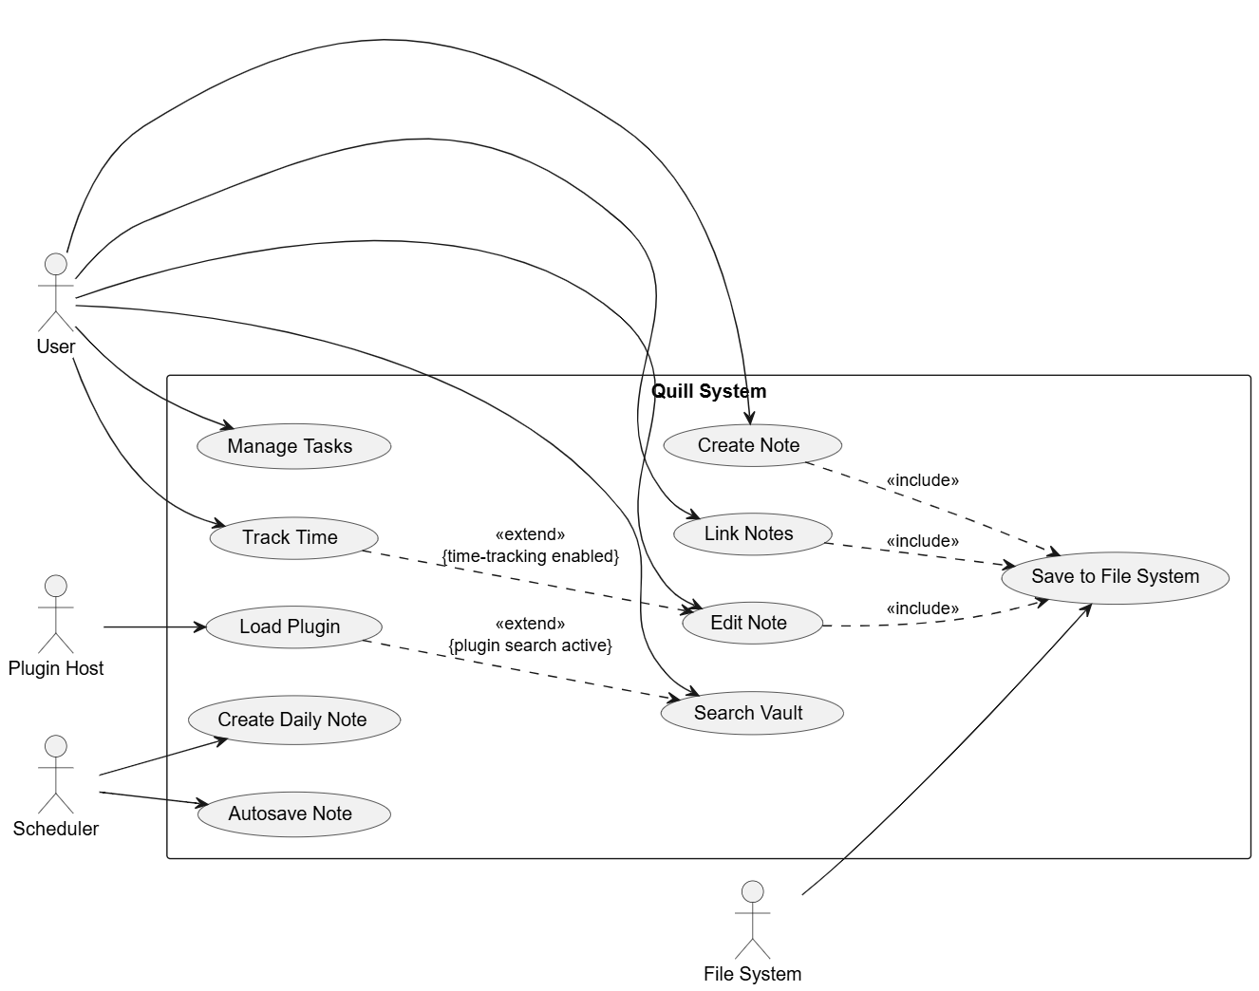
Figure 1: Use case diagram illustrating the interactions between the User, File System, Plugin Host, and Scheduler actors within the Quill productivity system, showing core use cases along with «include» and «extend» relationships.

Use case specifications.
Use Case 1: Create Note
- Primary Actor: User
- Stakeholders:
  - User: Wants to capture and organize information.
  - File System: Required to store the created data reliably.
- Preconditions: The Quill System is open, and the User has access to the current note vault.
- Postconditions: A new note is successfully created and saved to the File System via the «include» relationship.
- Trigger: The User initiates the action to create a new note (e.g., clicking a "New Note" button).
- Main Flow:
  - The User requests the system to create a new note.
  - The system generates a blank note interface.
  - The User inputs text into the note.
  - The system executes the included "Save to File System" use case.
  - The File System saves the note's data to the designated local storage.
  - The system confirms the save and displays the active note to the User.
- Alternate Flows:
  - Alternate Flow 1 (Invalid Title/Filename): At step 4, if the system attempts to save the note but the auto-generated title contains illegal file characters, the system prompts the User to enter a valid title. Once entered, the flow resumes at step 4.
  - Alternate Flow 2 (Storage Full): At step 5, if the File System cannot complete the save due to insufficient storage space, the system alerts the User of the error, retains the note content in temporary memory, and aborts the save process until space is freed.

Use Case 2: Search Vault
- Primary Actor: User
- Stakeholders:
  - User: Wants to find specific notes or information quickly.
  - Plugin Host: May provide extended search capabilities.
- Preconditions: The Quill System is running, and at least one note exists within the user's vault.
- Postconditions: The system displays a list of notes or contents matching the User's search query.
- Trigger: The User enters a query into the system's search bar.
- Main Flow:
  - The User inputs a search term.
  - The system scans the vault for exact and partial matches to the query.
  - The system compiles a list of matching notes.
  - The system presents the search results to the User.
- Alternate Flows:
  - Alternate Flow 1 (Plugin Search Active): At step 2, if the "plugin search active" condition is met, the system extends the search process to include the "Load Plugin" use case. The system utilizes the Plugin Host to perform advanced or specialized queries. The flow then resumes at step 3 with the combined results.
  - Alternate Flow 2 (No Results Found): At step 3, if the system finds zero matches for the inputted query, it skips step 4 and instead displays a "No results found" message, prompting the User to try different keywords.

Use Case 3: Create Daily Note
- Primary Actor: Scheduler
- Stakeholders:
  - User: Wants a fresh, dated note ready for daily logging without manual setup.
  - Scheduler: Needs to execute background tasks accurately based on time.
- Preconditions: The daily note feature is enabled in the system settings, and a default daily template is configured.
- Postconditions: A new note titled with the current date is created in the vault.
- Trigger: The internal system clock matches the configured time for the Scheduler to generate the daily note.
- Main Flow:
  - The Scheduler automatically triggers the "Create Daily Note" action.
  - The system checks the current system date.
  - The system creates a new note titled with the current date format.
  - The system applies the default daily note template to the new note.
  - The system saves the newly generated note.
- Alternate Flows:
  - Alternate Flow 1 (Note Already Exists): At step 3, if the system detects that a note with the current date's title already exists in the designated folder (e.g., the User manually created it earlier), the system aborts the creation process to prevent overwriting user data.
  - Alternate Flow 2 (Missing Template): At step 4, if the system cannot locate the configured daily note template, it bypasses the template application process and generates a completely blank note titled with the current date, ensuring the daily note is still created.

